Assignment DA3

Multivariate analysis of Turbidity at Veas

Torbjørn Madsen, 245861

Isak Skeie,

Multivariate Data Analysis

IIA2117

2023, xx March

table of contents

1 Introduction 2

2 Methods 2

3 Results 2

4 Conclusion 2

# Introduction

Veas is an wastewater treatment plant that uses biological methods to treat effluent. To ascertain the quantity of particles in the water, the level of turbidity is assessed prior to the biological treatment process. The volume of aluminum and iron needed for the cleaning process is controlled based on these parameters.

Nevertheless, turbidity levels above a certain threshold can slow down cleaning, making it take hours to fix the mistake. To address this issue, Veas has put into place an application called Intelicy, which has the ability to produce a "Blackbox" that shows the turbidity level. By choosing the inputs for the model and leaving the rest to the software, process engineers and operators can develop machine learning models quickly with Intelicy.

This report examines the effects of various parameters on turbidity levels in an effort to test the model created by Intelicy. Additionally, it will explore whether Principal Component Analysis (PCA) and Partial Least Squares (PLS) can be used to produce better models.

# Methods

## PCA

Test fra torbjørn

## PCR

## PLS

### Finding outliers

To determine if the comments on the picture were outliers, one had to examine them using unscrambler x and analyze all the variables present at that time. Only after this process could it be concluded that these comments were indeed outliers.

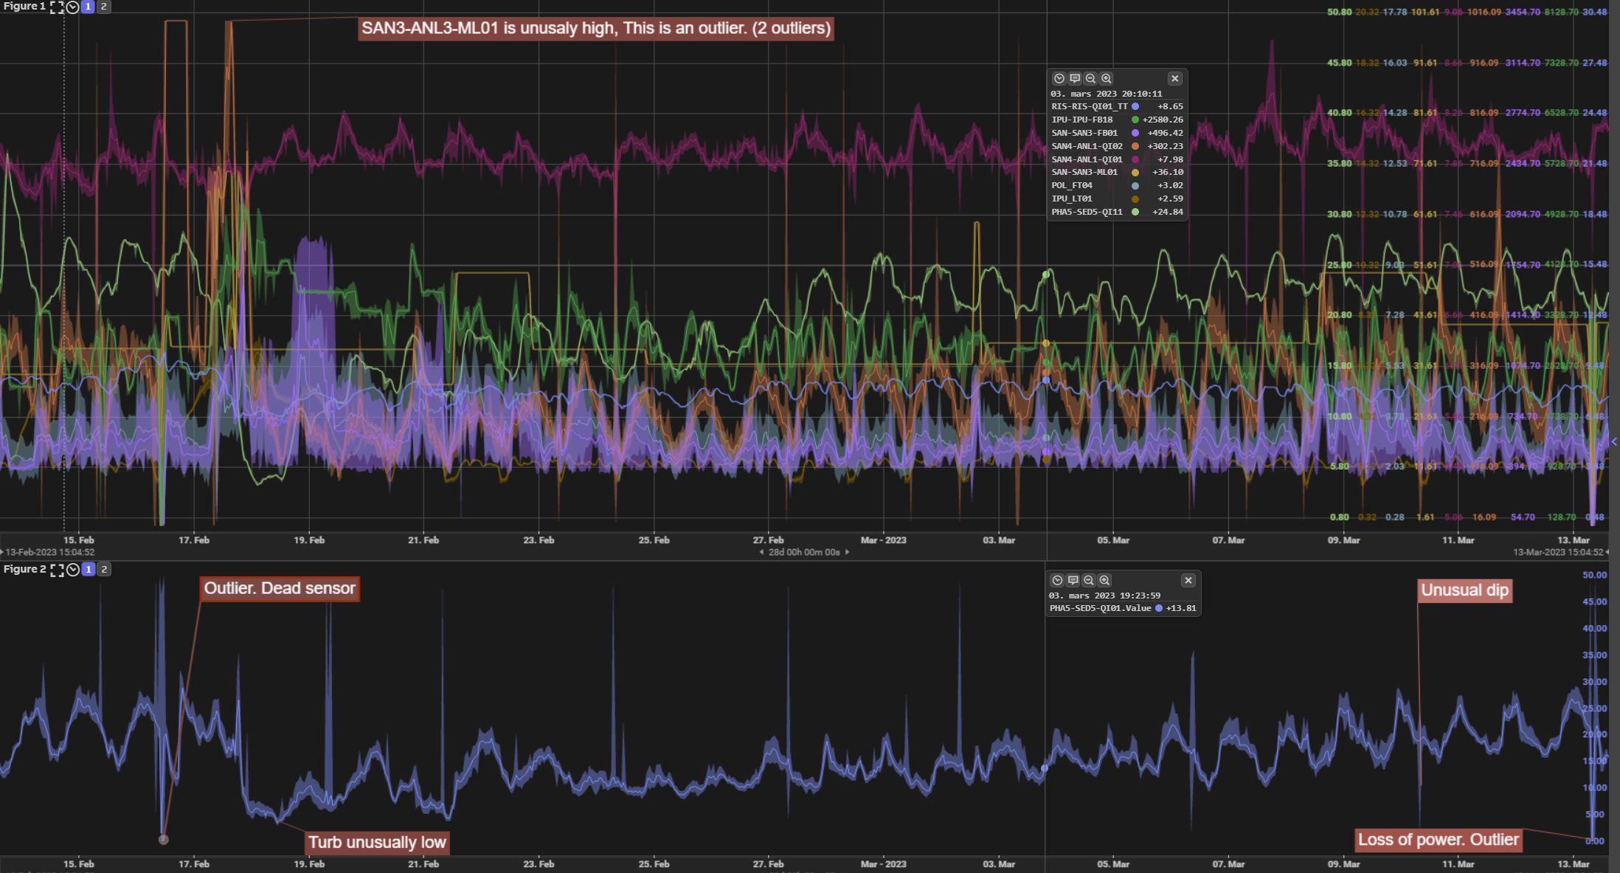

# Results

## PLS

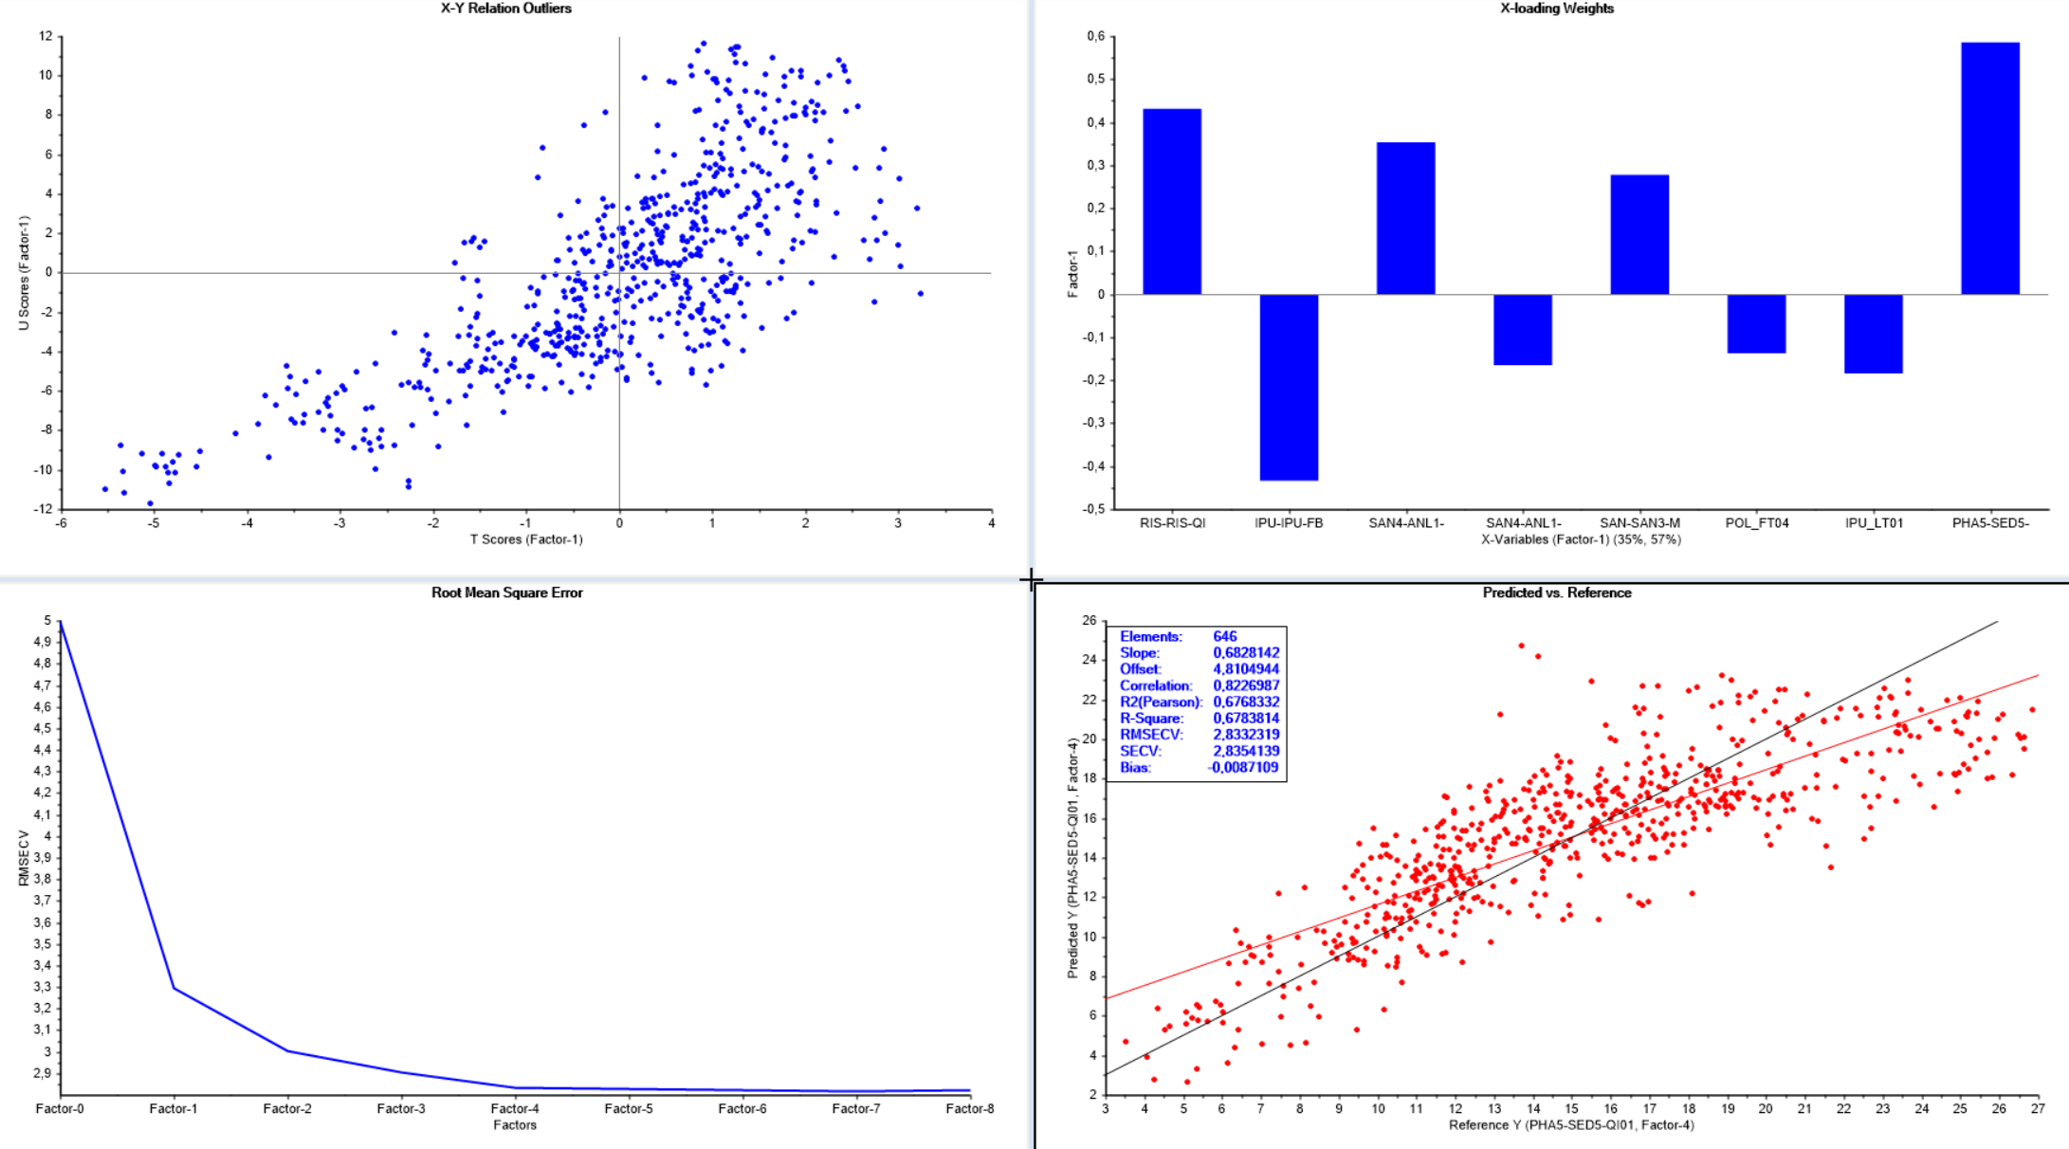

# Conclusion

# Notes

## PLS note 1

POL_FT04 and SAN-SAN3-FB01 is almost the same just with a scaling factor

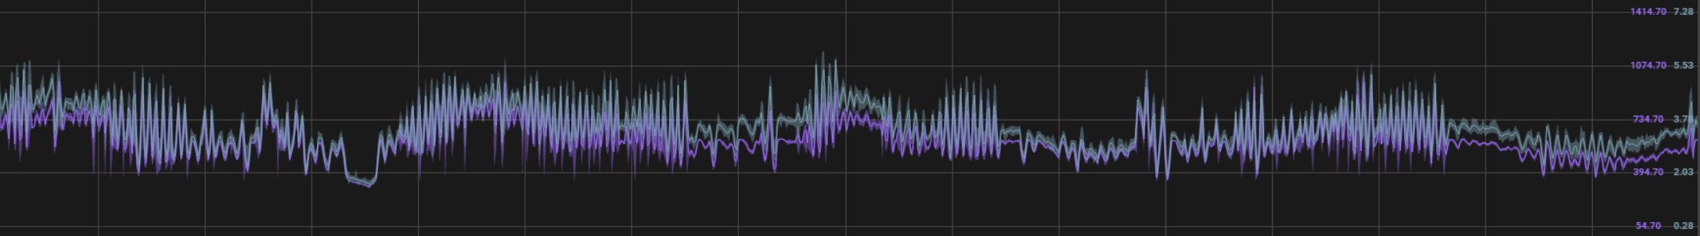

fjerne SAN-SAN3-FB01